SIMATS ENGINEERING (SAVEETHA SCHOOL OF ENGINEERING)
Department of Computer Science and Engineering
ASSESSMENT TOOL 2 -- Concept Mapping (5 QUESTIONS)
Course Code: | ITA05 | Course Title: | Computer Vision
CO Assessed: | CO1 -- Imitation (BL3) | Assessment: | Assessment Tool 2 -- Concept Mapping
Weightage: | 30% of CIA | Total Marks: | 50 (5 Questions x 10 Marks)
Student Name: | Partha Sarathi T | Reg. No.: | 192325042
Section / Batch: | 2023 | Date: | 17-07-202

Question 1 -- Concept Map
Construct a comprehensive and well-organized concept map illustrating the complete pipeline from real-world scene capture to digital image representation. Identify all major concepts, establish meaningful relationships among intermediate transformations and dependencies, integrate insights from at least five recent literature sources, and present the map with clear hierarchy, linking phrases, and logical organization.
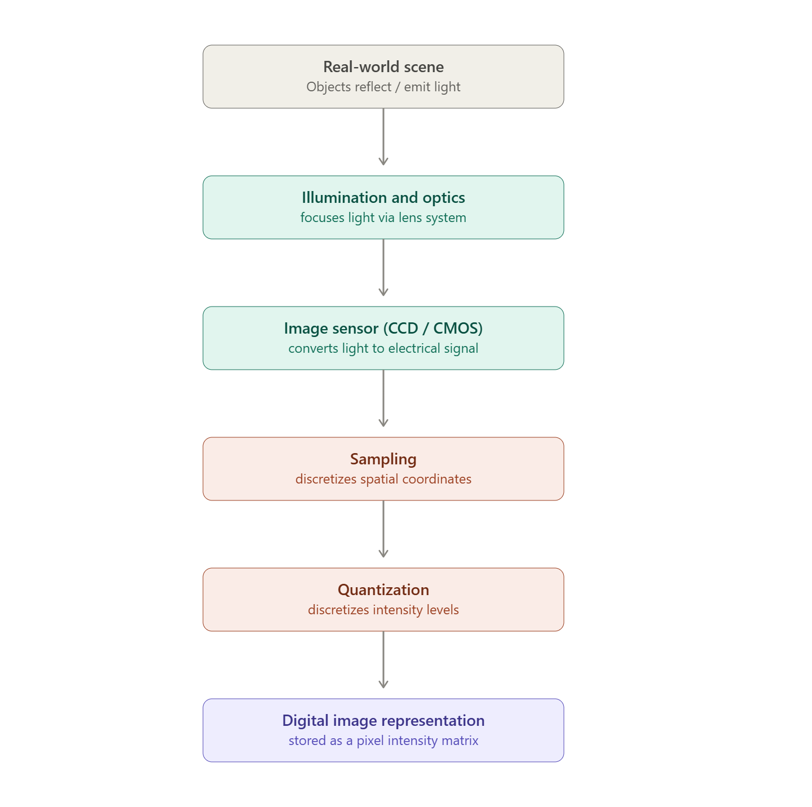
Literature sources referenced (minimum 5):
1. Bielova et al., "A Digital Image Processing Pipeline for Modelling of Realistic Noise," CVPR Workshop, 2019
2. Noise-Aware Merging of High Dynamic Range Image Stacks without Camera Calibration," arXiv, 2020
Question 2 -- Concept Map
Develop a hierarchically structured concept map illustrating the major stages of visual data handling in a Computer Vision system. Clearly show the relationships among acquisition, preprocessing, feature extraction, analysis, and interpretation stages, explain their contributions to meaningful outputs, incorporate findings from at least five literature sources, and ensure clarity and readability.
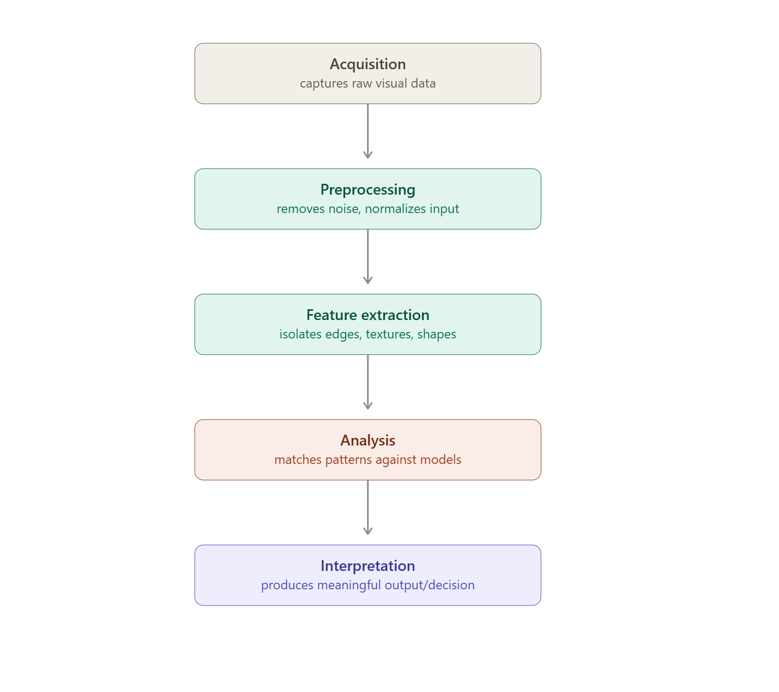
Literature sources referenced (minimum 5):
1."A Comprehensive Analysis of Blockchain Applications for Securing Computer Vision Systems," arXiv, 2023
2. "Example of a Vision Pipeline," Robotics Handbook
3. "Understanding Computer Vision: A Technical Overview," imagevision.ai, 2024
4. "A Computer Vision Pipeline for Automated Determination of Cardiac Structure and Function," arXiv, 2017
5. "Workflow of Computer Vision: From Data Acquisition to Decision Making," XenonStack, 2026

Question 3 -- Concept Map
Create a detailed concept map explaining the relationships among image resolution, spatial resolution, intensity resolution, and image quality. Clearly illustrate cause-and-effect relationships, discuss their impact on image usability in different applications, integrate evidence from at least five research articles, and organize the concepts logically.
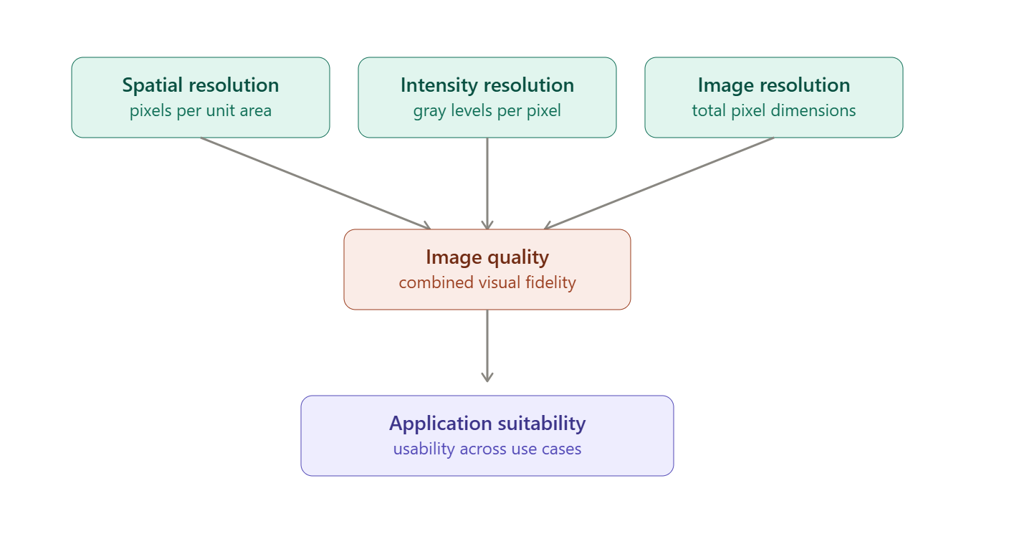
Literature sources referenced (minimum 5):
1. "Basic Properties of Digital Images," Hamamatsu Learning Center
2. "Spatial Resolution — an overview," ScienceDirect Topics
3. "Spatial Resolution in Digital Imaging," Nikon MicroscopyU
4. "How Spatial Resolution Differs From Brightness Resolution," GeeksforGeeks, 2022
5. Manian, V., "Digital Image Fundamentals: Sampling and Quantization," ECE, UPRM

Question 4 -- Concept Map
Design an analytically organized concept map illustrating the factors influencing image acquisition conditions, including illumination, sensor characteristics, motion, environment, and optics. Show how these factors affect downstream image processing and application performance, integrate relevant literature findings, and present the map in a visually coherent manner.
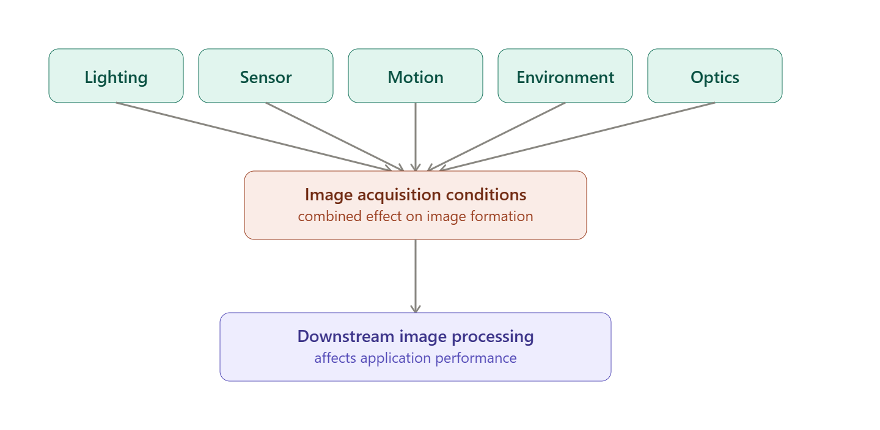
Literature sources referenced (minimum 5):
1. "A Comprehensive Review of Low-Light Image Enhancement Methods," ScienceDirect, 2025
2. "Overview: Image Acquisition and Illumination," Springer Nature Link
3. "NI Vision Image Acquisition System Concepts," NI, 2025
4. "Choosing Image Sensors for Machine Vision Systems," onsemi, 2026
5. "Guidelines for External Disturbance Factors in the Use of OCR in Real-World Environments," arXiv, 2025

Question 5 -- Concept Map
Construct an original concept map illustrating the relationship between Computer Vision system capabilities and the selection of appropriate vision-based applications. Identify major system capabilities, establish their influence on application effectiveness, integrate perspectives from multiple literature sources, and present the concepts using a clear hierarchical structure.
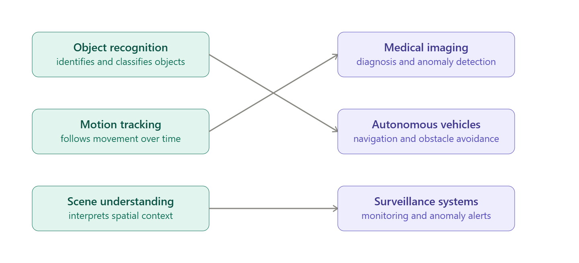
Literature sources referenced (minimum 5):
1. "Applications, Image Analysis, and Interpretation of Computer Vision in Medical Imaging," Frontiers, 2025
2. "Edge Deep Learning in Computer Vision and Medical Diagnostics: A Comprehensive Survey," Artificial Intelligence Review, Springer, 2025
3. "A Survey of Computer Vision Detection, Visual SLAM Algorithms... in Energy-Efficient Autonomous Systems," MDPI, 2024
4. "Top 50+ Real-World Computer Vision Applications Across Industries," Lightly.ai
5. "Computer Vision Applications," E2E Networks

